Host-parasite-clocks

Biplabendu Das, Charissa de Bekker

## Overview/Goals

This document provides a step-by-step guide that demonstrates how we (1) built a circadian gene co-expression network (GCN), (2) how we functionally annotated the network using previously published data, and (3) inferred functions of gene-clusters-of-interest to conduct the analysis in de Bekker and Das, 2022, Parasit. Immunol..

## Step 1: Build circadian GCN

### 1.1 Load data

We have built a circadian GCN for the ant, *Camponotus floridanus*, using time-course RNASeq data collected in Das and de Bekker (2021; bioRxiv). The raw data is deposited in NCBI under BioProject PRJNA704762.

**Description of the dataset:** Three forager and three nurse ant brains were sampled and pooled for RNA extraction and Illumina sequencing, every 2h over a 24h period. This resulted in 24 RNASeq datasets for ant brains (12 forager and 12 nurse datasets over the course of a 24h LD 12:12 day).

Prior to conducting the analyses listed below, we performed the usual steps (i.e., reads trimming, reads mapping to the genome, and normalizing mapped reads) to obtain the normalized gene expression data for each gene in the genome, at each time point, throughout the 24h day.

To build the GCN, we have organized the processed data into a [gene-expr X time-point] format, in a chronological order, as shown below.

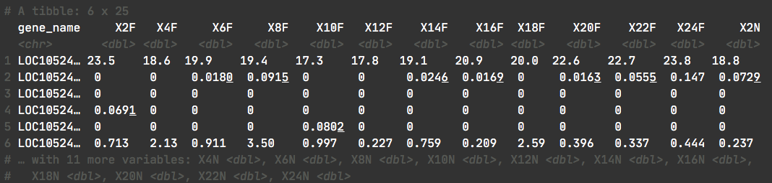

X2F = forager brain sampled at ZT2 (2h after lights were turned on), X4F = forager brain sampled at ZT4, and so on.

Reading the data into R was done as follows:

# loading database which contains data for Das and de Bekker 2021 (bioRxiv)  
db <- dbConnect(RSQLite::SQLite(), paste0(path_to_repo,"/data/databases/TC5_data.db"))  
  
# extract the (gene-expr X time-point) data  
dat <-  
 db %>%  
 tbl(., "annot_fpkm") %>%  
 select(gene_name, X2F:X24N) %>%  
 collect()  
  
dim(dat)

## [1] 13813 25

### 

### 1.2 Clean data

The above dataset contains all genes (n=13,813) in the ant genome. However, not all of these genes are expressed in the ant brain, and some are expressed at very low levels that are not biologically meaningful.

Therefore, we only kept the genes that are “expressed” (≥1 FPKM) in the ant brain, for at least half of all the sampled time points.

# Which genes are expressed throughout the day in both forager and nurses brains?  
daily.exp.genes <-  
 tbl(db, "expressed_genes") %>% # note, the information is already available in the database  
 filter(exp_half_for == "yes" & exp_half_nur == "yes") %>%  
 collect() %>%  
 pull(gene_name)  
  
# Subset the gene-expr X time-point file  
dat <- dat %>% filter(gene_name %in% daily.exp.genes)  
dim(dat)

## [1] 9139 25

This resulted in our cleaned, input data file. The daily expression for these 9139 genes has been used to create the circadian GCN of *Camponotus floridanus*.

### 

### 1.3 Format data

To create the ant GCN, the expression similarity (co-expression) of different gene pairs needs to be calculated. To do so, we normalized the gene expression data by log2-transformation as demonstrated below (Figure 1).

datExpr = as.data.frame(t(log2(dat[-c(1)]+1)))  
names(datExpr) = dat$gene_name  
rownames(datExpr) = names(dat)[-c(1)]

# ----------------------------------------------------------- #  
# USE THE FOLLOWING CODE TO CHECK IF YOU HAVE ANY BAD SAMPLES #  
# ----------------------------------------------------------- #  
 # gsg = goodSamplesGenes(datExpr0, verbose = 3);  
 # gsg$allOK  
 #  
 # sampleTree = hclust(dist(datExpr0), method = "average");  
 # # Plot the sample tree: Open a graphic output window of size 12 by 9 inches  
 # # The user should change the dimensions if the window is too large or too small.  
 # sizeGrWindow(12,9)  
 # #pdf(file = "Plots/sampleClustering.pdf", width = 12, height = 9);  
 # par(cex = 1);  
 # par(mar = c(0,4,2,0))  
 # plot(sampleTree, main = "Sample clustering to detect outliers", sub="", xlab="", cex.lab = 1.5,  
 # cex.axis = 1.5, cex.main = 2)  
# ----------------------------------------------------------- #  
  
# save the number of genes and samples  
# that will be used to create the circadian GCN  
nGenes = ncol(datExpr)  
nSamples = nrow(datExpr)  
  
# visualize the log-transformed data  
x = reshape2::melt(as.matrix(t(datExpr)))  
colnames(x) = c('gene_id', 'sample', 'value')  
ggplot(x, aes(x=value, color=sample)) + geom_density() + theme_Publication()

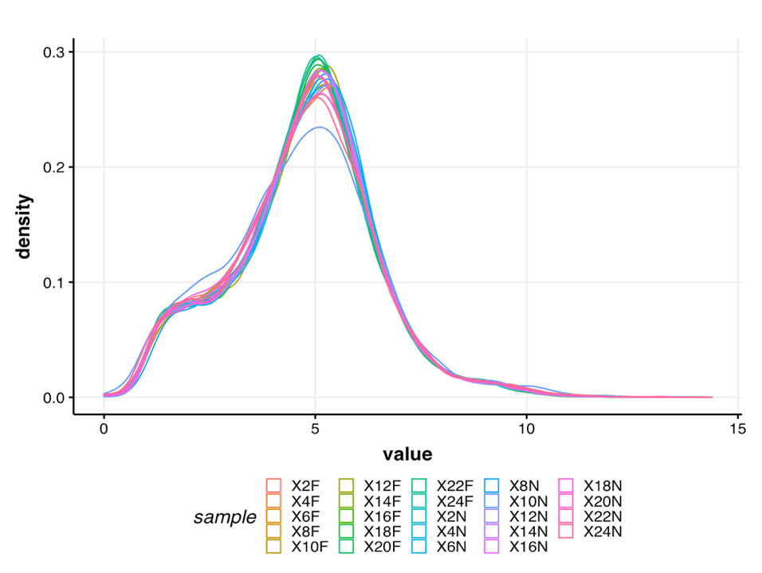

*Figure 1. Normalized gene expression: The density plot above shows the distribution of log2-transformed gene expression values for each sample.*

### 1.4 Calculate gene-gene similarity

Subsequently, we calculated the pairwise gene expression similarity for each of the 9139 genes and saved it to a matrix.

We calculated expression similarity for all gene pairs in a dataset using Kendall’s tau, which measures the ordinal relationship between two variables and is used in rhythmicity detection algorithms [1] (Figure 2).

## Calculate Kendall's tau-b correlation for each gene-gene pair  
#  
# sim_matrix <- cor((datExpr), method = "kendall") # this step takes time  
# save(sim_matrix, file = paste0(path_to_repo, "/results/temp_files/sim_matrix_for_nur_TC5.RData")) # might be useful to save the sim_matrix and  
load(paste0(path_to_repo, "/results/temp_files/sim_matrix_for_nur_TC5.RData")) # load it up  
  
## Let's display a chunk of the matrix (code from Hughitt 2016; github)  
heatmap_indices <- sample(nrow(sim_matrix), 500)  
gplots::heatmap.2(t(sim_matrix[heatmap_indices, heatmap_indices]),  
 col=inferno(100),  
 labRow=NA, labCol=NA,  
 trace='none', dendrogram='row',  
 xlab='Gene', ylab='Gene',  
 main='Similarity matrix \n correlation method = "kendall" \n (500 random genes)',  
 density.info='none', revC=TRUE)

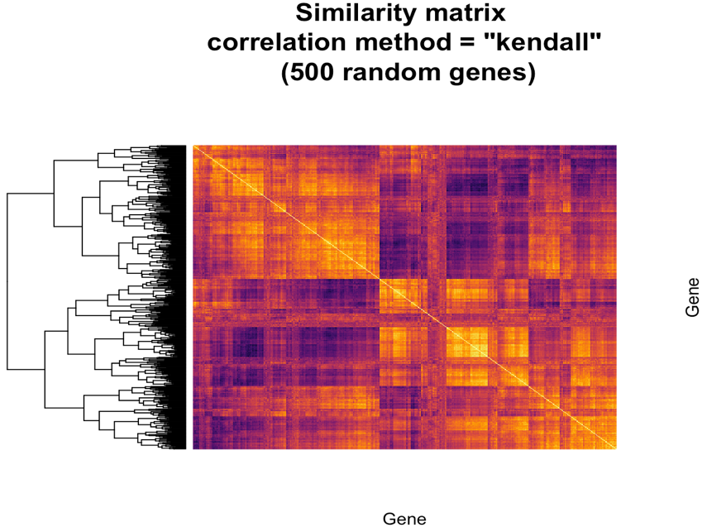

*Figure 2. Similarity matrix: The heatmap shows the pairwise Kendall’s tau correlation for a set of 500 genes randomly pulled from the 9139 genes expressed in the ant brain.*

### 1.5 Create adjacency matrix

From the above similarity matrix, we created the adjacency matrix needed for constructing a gene co-expression network.

To create the adjacency matrix, we first identified the soft-thresholding power by calling the network topology analysis function from the WGCNA package [2].

# Choose a set of soft-thresholding powers  
powers = c(c(1:10), seq(from = 12, to=20, by=2))  
# # Call the network topology analysis function  
sft = pickSoftThreshold(datExpr, powerVector = powers, verbose = 5)

## pickSoftThreshold: will use block size 4895.  
## pickSoftThreshold: calculating connectivity for given powers...  
## ..working on genes 1 through 4895 of 9139  
## ..working on genes 4896 through 9139 of 9139  
## Power SFT.R.sq slope truncated.R.sq mean.k. median.k. max.k.  
## 1 1 0.845 1.900 0.995 3310.0 3390.00 4730  
## 2 2 0.248 0.276 0.930 1720.0 1710.00 3200  
## 3 3 0.343 -0.284 0.907 1050.0 988.00 2410  
## 4 4 0.696 -0.580 0.922 701.0 616.00 1930  
## 5 5 0.818 -0.762 0.951 499.0 402.00 1600  
## 6 6 0.847 -0.896 0.942 371.0 272.00 1360  
## 7 7 0.854 -0.992 0.933 285.0 190.00 1180  
## 8 8 0.868 -1.060 0.935 225.0 136.00 1030  
## 9 9 0.879 -1.110 0.940 181.0 99.10 919  
## 10 10 0.874 -1.160 0.928 148.0 73.40 824  
## 11 12 0.879 -1.220 0.928 103.0 42.20 676  
## 12 14 0.879 -1.280 0.921 74.8 25.40 568  
## 13 16 0.874 -1.310 0.916 56.1 15.80 485  
## 14 18 0.842 -1.360 0.884 43.2 10.10 420  
## 15 20 0.827 -1.390 0.874 34.0 6.64 367

# Plot the results:  
# sizeGrWindow(9, 5)  
# par(mfrow = c(1,2));  
cex1 = 0.9;  
# Scale-free topology fit index as a function of the soft-thresholding power  
plot(sft$fitIndices[,1], -sign(sft$fitIndices[,3])*sft$fitIndices[,2],  
 xlab="Soft Threshold (power)",ylab="Scale Free Topology Model Fit,signed R^2",type="n",  
 main = paste("Scale independence"));  
text(sft$fitIndices[,1], -sign(sft$fitIndices[,3])*sft$fitIndices[,2],  
 labels=powers,cex=cex1,col="red");  
# this line corresponds to using an R^2 cut-off of h  
abline(h=0.90,col="red")

# Mean connectivity as a function of the soft-thresholding power  
plot(sft$fitIndices[,1], sft$fitIndices[,5],  
 xlab="Soft Threshold (power)",ylab="Mean Connectivity", type="n",  
 main = paste("Mean connectivity"))  
text(sft$fitIndices[,1], sft$fitIndices[,5], labels=powers, cex=cex1,col="red")

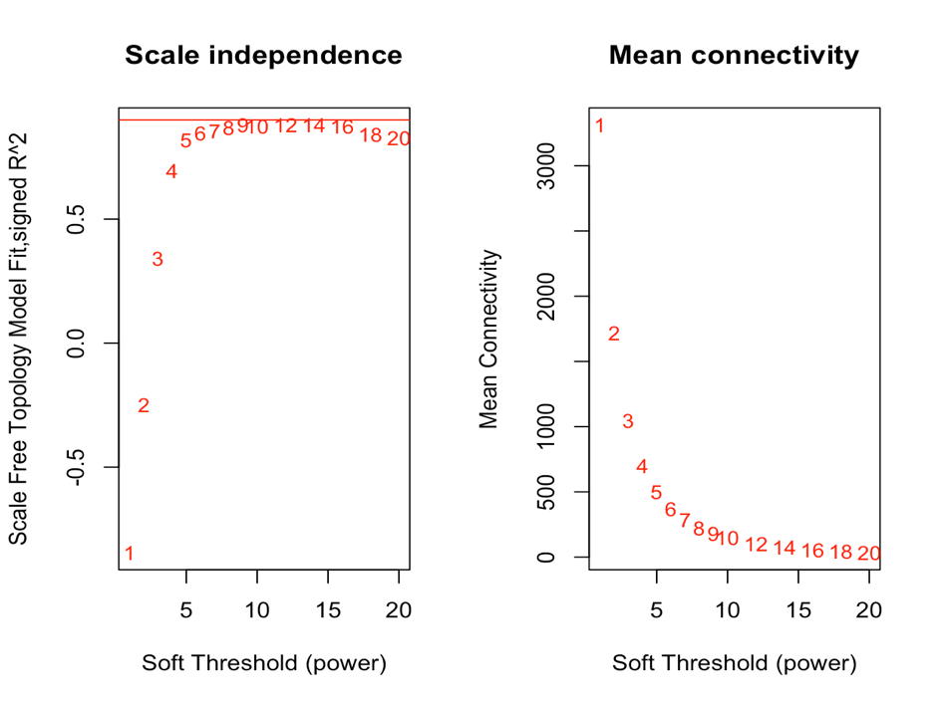

*Figure 3. Soft-thresholding power: The plots show the effect of soft-thresholding power on the topology and the mean connectivity of the transformed similarity matrix (network).*

The scale-free topology fit index reaches ~0.9 at a soft-thresholding power of 9 without drastically improving beyond that (Figure 3). As such, we set our soft thresholding power to 9 for creating the adjacency matrix (Figure 4).

## Specify the soft-thresholding-power  
soft.power = 9  
  
## Construct adjacency matrix  
# adj_matrix <- adjacency.fromSimilarity(sim_matrix,  
# power=soft.power,  
# type='signed'  
# )  
# save(adj_matrix, file = paste0(path_to_repo, "/results/temp_files/adj_matrix_for_nur_TC5.RData")) # might be useful to save the sim_matrix and  
load(paste0(path_to_repo, "/results/temp_files/adj_matrix_for_nur_TC5.RData")) # load it up

# Convert adj_matrix to matrix  
gene_ids <- rownames(adj_matrix)  
  
adj_matrix <- matrix(adj_matrix, nrow=nrow(adj_matrix))  
rownames(adj_matrix) <- gene_ids  
colnames(adj_matrix) <- gene_ids  
  
## Same heatmap as before, but now with the power-transformed adjacency matrix  
gplots::heatmap.2(t(adj_matrix[heatmap_indices, heatmap_indices]),  
 col=inferno(100),  
 labRow=NA, labCol=NA,  
 trace='none', dendrogram='row',  
 xlab='Gene', ylab='Gene',  
 main='Adjacency matrix',  
 density.info='none', revC=TRUE)

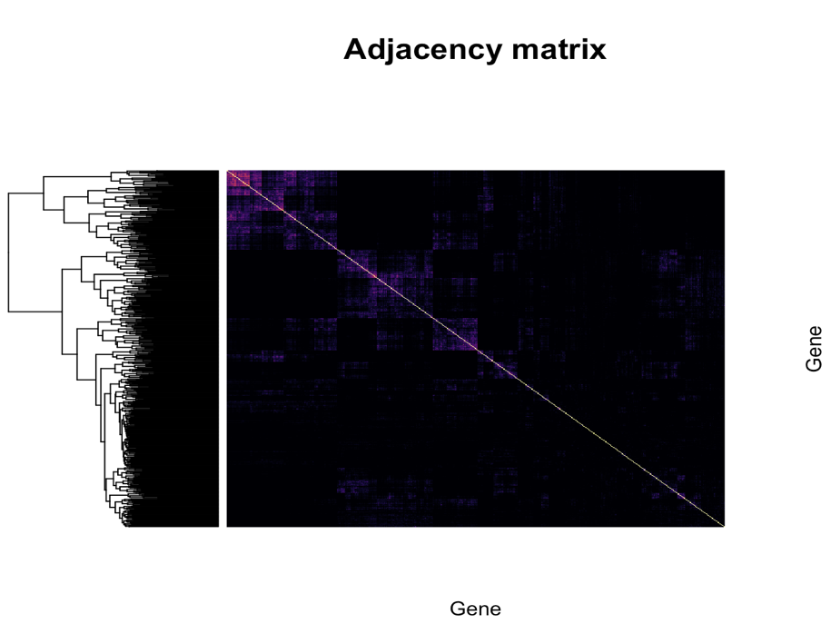

*Figure 4. Adjacency matrix: The heatmap shows the result of the power-transformation on the similarity of the 500 random genes shown previously in Figure 2. Only the highest pair-wise correlations are retained whereas the weak correlations tend to zero.*

## Step 2: Identify gene clusters

### 2.1 Create topological overlap matrix

To identify clusters of similarly expressed genes, first a topological overlap matrix (TOM) needed to be constructed, which was subsequently used for hierarchical clustering (Figure 5).

# Turn adjacency into topological overlap  
# TOM = TOMsimilarity(adj_matrix);  
# dissTOM = 1-TOM  
# save(dissTOM, file = paste0(path_to_repo, "/results/temp_files/dissTOM_for_nur_TC5.RData")) # might be useful to save the sim_matrix and  
load(paste0(path_to_repo, "/results/temp_files/dissTOM_for_nur_TC5.RData")) # load it up  
  
# Call the hierarchical clustering function  
geneTree = hclust(as.dist(dissTOM), method = "average")  
  
# Plot the resulting clustering tree (dendrogram)  
# sizeGrWindow(12,9)  
plot(geneTree, xlab="", sub="", main = "Gene clustering on TOM-based dissimilarity",  
 labels = FALSE, hang = 0.04)

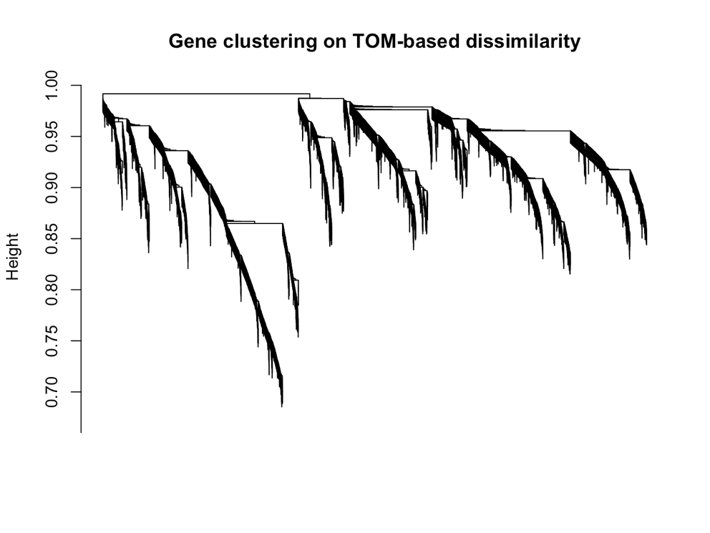

*Figure 5. Dendrogram: The depicted clustering tree resulted from hierarchical clustering of the TOM-based dissimilarity matrix and is used for identifying modules of highly similar genes in the co-expression network.*

### 

### 2.2 Identify clusters

To cluster genes with similar daily expression pattern into modules, we used the cutreeDynamic() function from the WGCNA package [2]. A minimum size for the identified modules needs to be provided. We aimed to identify fairly large modules that are biologically meaningful (i.e., enriched in different GO/PFAM terms). As such, we set the minimum module size to 30. Additionally, cluster identification can be refined at a later stage by merging similar modules. As such, the initial choice of minimum module size should not affect cluster identification drastically.

# We like large modules, so we set the minimum module size relatively high:  
minModuleSize = 30;  
  
# Module identification using dynamic tree cut:  
dynamicMods= cutreeDynamic(dendro = geneTree,  
 distM = dissTOM,  
 method = "hybrid",  
 verbose = 4,  
 deepSplit = 3, # see WGCNA for more info on tuning parameters  
 pamRespectsDendro = FALSE,  
 minClusterSize = minModuleSize);

## ..cutHeight not given, setting it to 0.99 ===> 99% of the (truncated) height range in dendro.  
## ..Going through the merge tree  
##   
## ..Going through detected branches and marking clusters..  
## ..Assigning Tree Cut stage labels..  
## ..Assigning PAM stage labels..  
## ....assigned 5531 objects to existing clusters.  
## ..done.

# Convert numeric lables into colors  
dynamicColors = labels2colors(dynamicMods)  
table(dynamicColors)

## dynamicColors  
## black blue brown cyan darkgreen   
## 515 1172 742 149 79   
## darkgrey darkorange darkred darkturquoise green   
## 72 56 88 75 720   
## greenyellow grey60 lightcyan lightgreen lightyellow   
## 269 112 134 107 99   
## magenta midnightblue orange pink purple   
## 369 134 66 506 299   
## red royalblue saddlebrown salmon skyblue   
## 579 91 45 199 50   
## steelblue tan turquoise white yellow   
## 32 265 1337 55 723

### 2.3 Merge similar modules

In the initial module identification step, WGCNA found 30 modules. However, some of the identified modules might have very similar expression pattern, which would indicate that they are closely related and warrants their merging. We have done this based on the calculation and hierarchical clustering of the eigengene values of modules (Figure 6).

# Calculate eigengenes  
MEList = moduleEigengenes(datExpr, colors = dynamicColors)  
MEs = MEList$eigengenes  
  
# Calculate dissimilarity of module eigengenes  
MEDiss = 1-cor(MEs, method = "kendall");  
  
# Cluster module eigengenes  
METree = hclust(as.dist(MEDiss), method = "average");  
# Plot the result  
# sizeGrWindow(7, 8)  
plot(METree, main = "Clustering of module eigengenes",  
 xlab = "", sub = "MEDiss = 1-cor(MEs, method = 'kendall')")  
  
# We choose a height cut of 0.2, corresponding to correlation of 0.8, to merge  
MEDissThres = 0.2 # user-specified parameter value; see WGCNA manual for more info  
  
# Plot the cut line into the dendrogram  
abline(h=MEDissThres, col = "red")

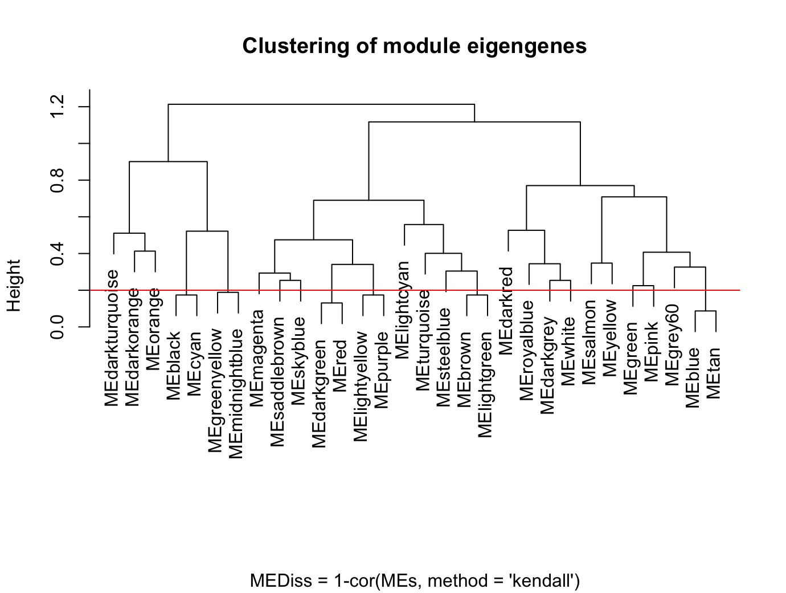

*Figure 6. Merging similar modules: The dendrogram shows the similarity of the different gene modules using hierarchical clustering of the module’s eigenvalue (eigengene expression). The horizontal red line shows the cutoff used to merge similar modules.*

We chose a cut off height of 0.2 (Figure 6), corresponding to correlation of 0.8, to merge similar modules. Although arbitrary, the cutoff was motivated by the number of modules we wanted to retain in the GCN; in our case, a 0.2 threshold resulted in a total of 12 modules in the GCN (see below). After merging the similar modules, we visualized the module assignments before and after merging (Figure 7).

# Call an automatic merging function  
merge = mergeCloseModules(datExpr, dynamicColors, cutHeight = MEDissThres, verbose = 3)

## mergeCloseModules: Merging modules whose distance is less than 0.2  
## multiSetMEs: Calculating module MEs.  
## Working on set 1 ...  
## moduleEigengenes: Calculating 30 module eigengenes in given set.  
## multiSetMEs: Calculating module MEs.  
## Working on set 1 ...  
## moduleEigengenes: Calculating 13 module eigengenes in given set.  
## multiSetMEs: Calculating module MEs.  
## Working on set 1 ...  
## moduleEigengenes: Calculating 12 module eigengenes in given set.  
## Calculating new MEs...  
## multiSetMEs: Calculating module MEs.  
## Working on set 1 ...  
## moduleEigengenes: Calculating 12 module eigengenes in given set.

# The merged module colors  
mergedColors = merge$colors;  
# Eigengenes of the new merged modules:  
mergedMEs = merge$newMEs;  
  
# sizeGrWindow(12, 9)  
plotDendroAndColors(geneTree,  
 cbind(dynamicColors, mergedColors),  
 c("Dynamic Tree Cut", "Merged dynamic"),  
 dendroLabels = FALSE, hang = 0.03,  
 addGuide = TRUE, guideHang = 0.05)

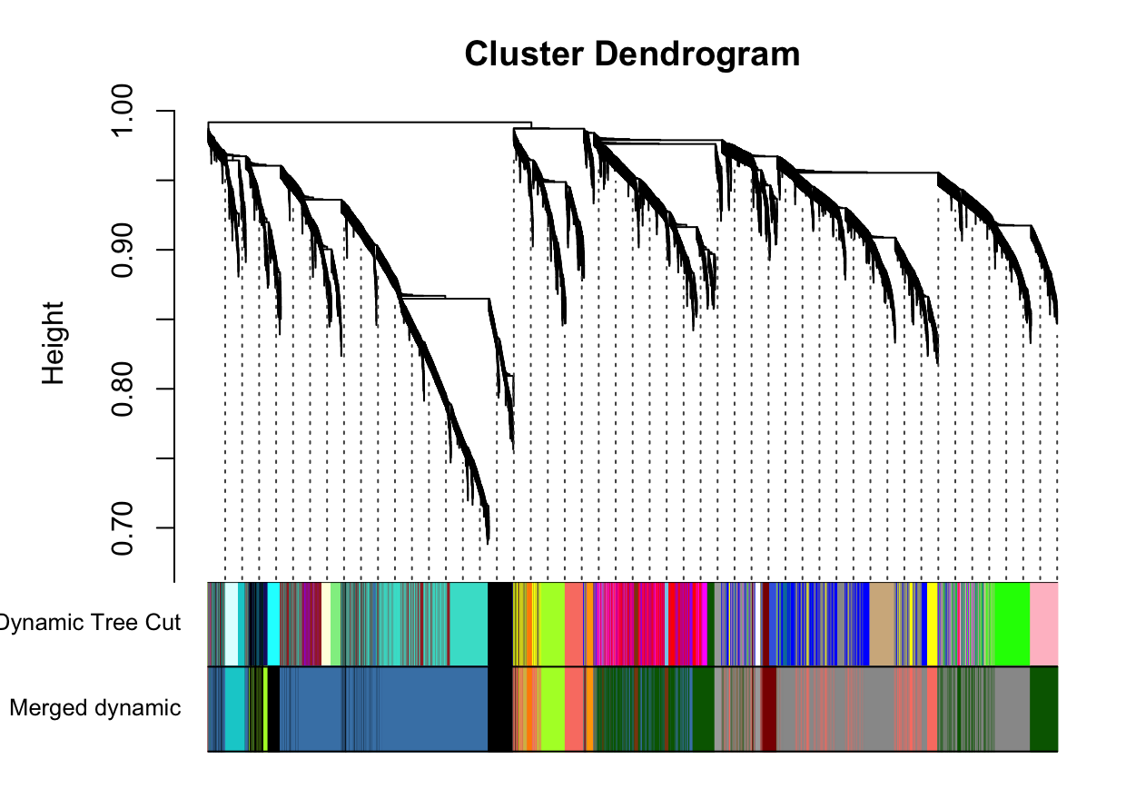

*Figure 7. Modules of highly co-expressed genes: The dendrogram and color scheme (representing colors assigned to individual modules) shows the results of module identification before (Dynamic Tree Cut) and after (Merged dynamic) similar modules were merged.*

# Rename to moduleColors  
moduleColors = mergedColors  
  
# Construct numerical labels corresponding to the colors  
colorOrder = c("grey", standardColors(50));  
moduleLabels = match(moduleColors, colorOrder)-1

Using the method, we identified 12 modules in the ant GCN, the size of each of these modules are shown below.

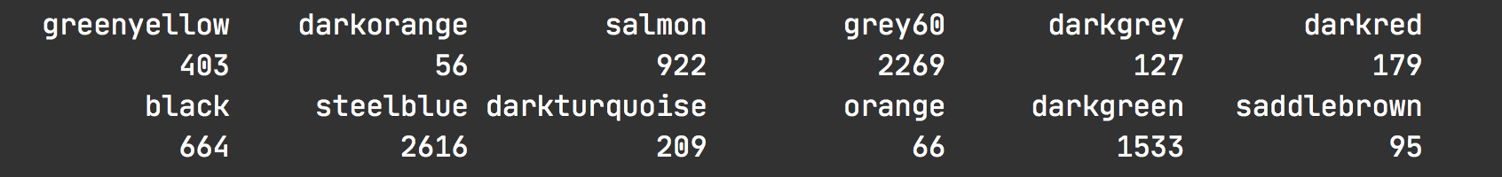

The standard output of WGCNA names the different modules as colors (see above), which have no specific meaning and can complicate data communication. Therefore, we renamed the modules according to the following convention prior to proceeding:

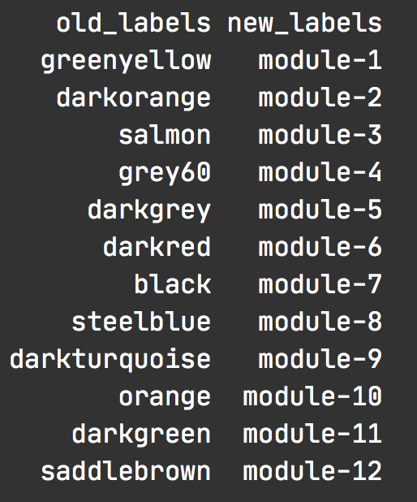

### 2.4 Calculate module-module similarity

After we created the ant GCN (adjacency matrix) and identified 12 modules of highly co-expressed genes in the network, we investigated how the different modules are connected to each other in the GCN. We calculated the module-module similarity using Kendall’s tau-b correlation for pairwise module-eigengene expression and used the resulting similarity matrix to create the module adjacency matrix (Figure 8).

# Calculate similarity of the eigen-genes  
sim_matrix_ME <- cor(mergedMEs, method = "kendall")  
  
# calculate adj_matrix  
adj_matrix_ME <- adjacency.fromSimilarity(sim_matrix_ME,  
 power=1, # DO NOT power transform  
 type='signed'  
)  
  
# coerce into a matrix  
  
## GET THE NAMES OF THE MODULES  
# module_ids <- rownames(adj_matrix_ME)  
## CHANGE THE NAMES OF THE MODULES  
module_ids <- data.frame(old_labels = rownames(adj_matrix_ME),  
 new_labels = paste0("module-", 1:nrow(adj_matrix_ME)))  
  
adj_matrix_ME <- matrix(adj_matrix_ME, nrow=nrow(adj_matrix_ME))  
rownames(adj_matrix_ME) <- module_ids$new_labels  
colnames(adj_matrix_ME) <- module_ids$new_labels

gplots::heatmap.2(t(adj_matrix_ME),  
 col=inferno(100),  
 # labRow=NA, labCol=NA,  
 trace='none', dendrogram='row',  
 xlab='', ylab='',  
 # main='Similarity matrix - MEs \n correlation method = "kendall")',  
 main='Adjacency matrix - MEs \n modified edge weights)',  
 density.info='none', revC=TRUE)

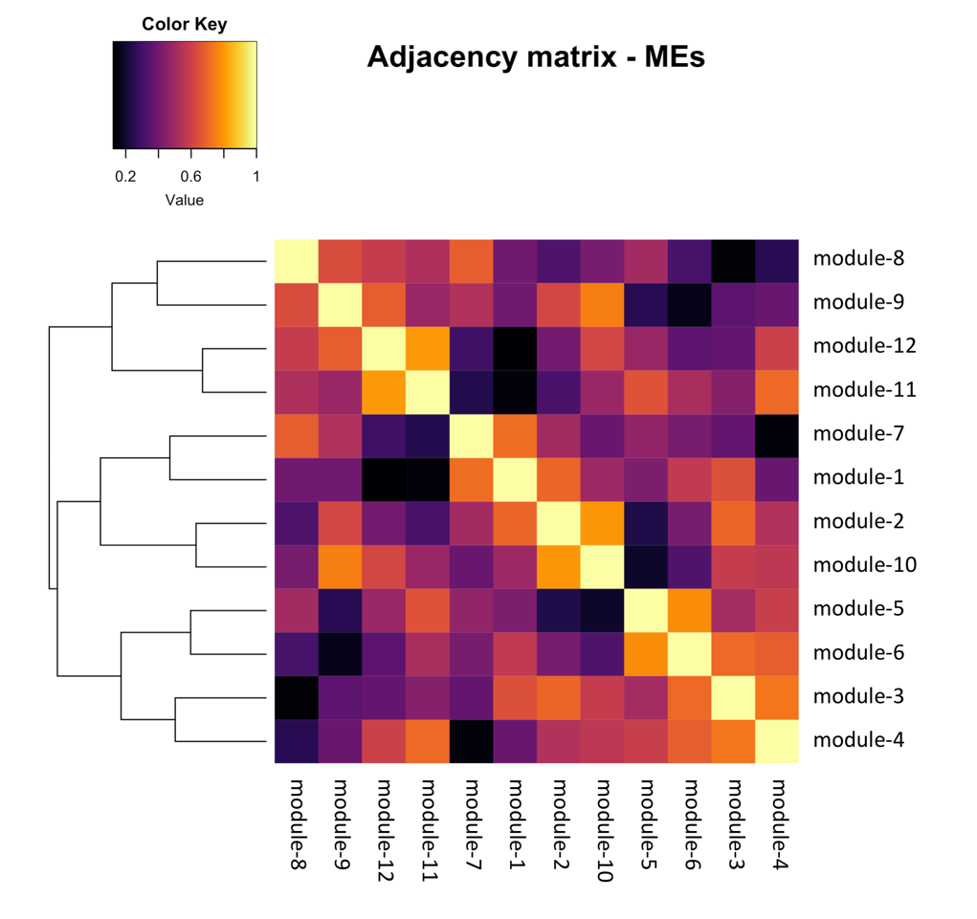

*Figure 8. Module-module relationships: The heatmap shows the pairwise Kendall’s tau correlation (similarity) of the twelve modules identified in the ant GCN. Darker shades indicate low correlations and brighter shades indicate high correlations, as indicated by the Color Key.*

### 2.5 Visualize the network

To better visualize the global network – how the modules are connected to each other – we simplified the network by removing most of the weak edges of the network and retaining only the strong module-module correlations. To remove weak edges, we set all correlations less than 0.6 to be zero. To simplify further, we assigned the same edge weight for all correlations between 0.6 and 0.8 (i.e., 0.5), and a different edge weight for correlations ≥ 0.8 (i.e., 1). We used the igraph package [3] in R to simplify and visualize the module-module relationships in the network (Figure 9).

pacman::p_load(igraph)  
  
# get rid of low correlations (0.6 & 0.8 are arbitrary)  
adj_matrix_ME[adj_matrix_ME < 0.6] <- 0  
adj_matrix_ME[adj_matrix_ME < 0.8 & adj_matrix_ME>0] <- 0.5  
adj_matrix_ME[adj_matrix_ME >= 0.8] <- 1  
  
# build_network  
network <- graph.adjacency(adj_matrix_ME,  
 mode = "upper",  
 weighted = T,  
 diag = F)  
  
# simplify network  
network <- igraph::simplify(network) # removes self-loops

colors <- mergedMEs %>% names() %>% str_split("ME", 2) %>% sapply("[", 2)  
V(network)$color <- colors  
  
genes_ME <- factor(moduleColors, levels=colors) %>% summary()  
V(network)$size <- log2(genes_ME)*2  
  
V(network)$label.color <- "black"  
V(network)$frame.color <- "white"  
  
E(network)$width <- E(network)$weight^2*4  
E(network)$edge.color <- "gray80"  
  
  
## Circular layout  
plot(network,  
 layout=layout.kamada.kawai,  
 vertex.shape="none"  
)

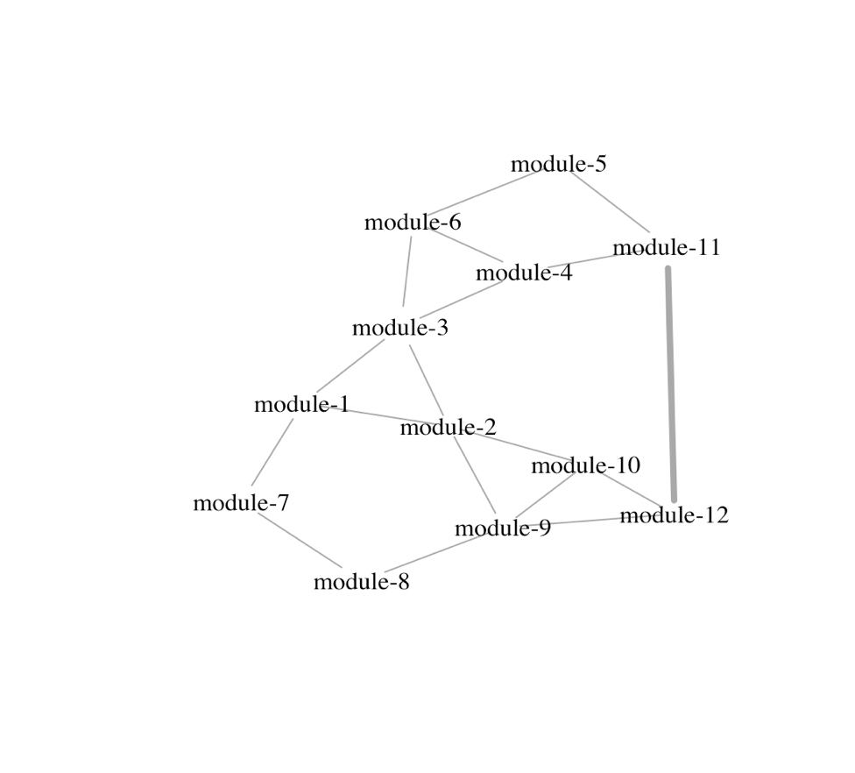

*Figure 9. Visualizing the ant GCN: A simplified view of the connectivity patterns between the different gene modules of the ant GCN are shown. In our case, thick edges between two modules indicate correlations ≥ 0.8, thinner edges indicate correlations between (0.6, 0.8), and no edges indicate correlations < 0.6.*

## Step 3: Annotate the network

After having created the ant GCN, we functionally annotated the network by identifying which modules contained our genes of interest. As such, we checked for significant overlap between a module in the network and our genes of interest using Fisher’s exact tests.

### 3.1 Define your genes of interest

We first aimed to identify the GCN modules that contained our 24h oscillating genes (for.rhy = 24h-rhythmic genes in forager brains, nur.rhy = 24h-rhythmic genes in nurses), 12h oscillating genes (for.rhy.12, nur.rhy.12), and 8h-rhythmic genes (for.rhy.8, nur.rhy.8).

# DEFINE GENES OF INTEREST  
  
rhy.trait.24 <- tbl(db, "ejtk_all") %>% select(gene_name:rhy) %>% collect()  
# pull the genes  
for.rhy <- rhy.trait.24 %>% filter(caste=="for" & rhy=="yes") %>% pull(gene_name)  
nur.rhy <- rhy.trait.24 %>% filter(caste=="nur" & rhy=="yes") %>% pull(gene_name)  
  
rhy.trait.8 <- tbl(db, "ejtk_8h_all") %>% select(gene_name:rhy) %>% collect()  
for.rhy.8 <- rhy.trait.8 %>% filter(caste=="for" & rhy=="yes") %>% pull(gene_name)  
nur.rhy.8 <- rhy.trait.8 %>% filter(caste=="nur" & rhy=="yes") %>% pull(gene_name)  
  
rhy.trait.12 <- tbl(db, "ejtk_12h_all") %>% select(gene_name:rhy) %>% collect()  
for.rhy.12 <- rhy.trait.12 %>% filter(caste=="for" & rhy=="yes") %>% pull(gene_name)  
nur.rhy.12 <- rhy.trait.12 %>% filter(caste=="nur" & rhy=="yes") %>% pull(gene_name)

We used a Fisher’s exact test to ask if there was a significant overlap between our genes of interest (e.g., for.rhy) and the modules in the GCN (e.g., module-7) in a pairwise manner.

For example, to check if the 24h-rhythmic genes in forager brains (for.rhy) were overrepresented in module-7, we first created a contingency table. To do so, we needed to define the background number of genes, i.e., the size of the set that contains all possible genes from which module-7 and for.rhy genesets were drawn. In our case, this consisted of the 9139 genes that were used to build the GCN. Using this information, we created the contingency table as shown below.

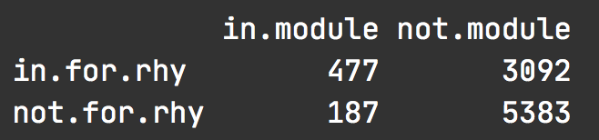

We found that 477 genes were present in both, for.rhy and module-7, genesets. Additionally, 3092 genes were present in for.rhy but not in module-7, whereas 187 genes occurred only in module-7 but not in for.rhy. Finally, 5383 genes of the background geneset were neither in rhy.for nor in module-7.

Having built the contingency table we conducted a Fisher’s exact test using the fisher.test() function in R. The results are shown below:

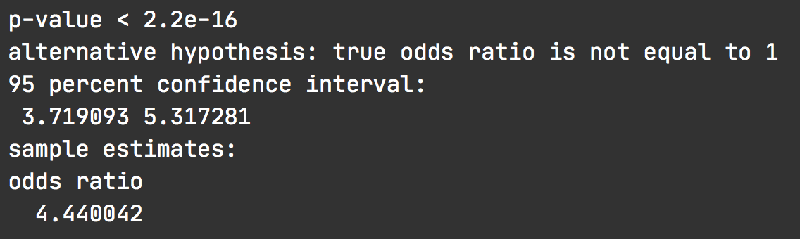

We found that the odds-ratio was approximately 4, which is significantly higher than 1 (p-value < 2e-16). In other words, the genes that showed 24h-rhythms in forager brains were significantly overrepresented in module-7 and vice-versa: the two sets show significant overlap.

### 3.2 Where are my genes of interest located?

To perform multiple Fisher’s exact test needed for our comparisons, we made use of the GeneOverlap package in R [4].

pacman::p_load(GeneOverlap)  
# https://www.bioconductor.org/packages/devel/bioc/vignettes/GeneOverlap/inst/doc/GeneOverlap.pdf  
  
# Make a list that returns gene names for a given cluster  
module_color = colors  
module = names(mergedMEs)  
module_colors <-  
 data.frame(module_label=module) %>%  
 mutate(module_color = str_replace(module_label, "ME", ""))  
  
module_genes <- list()  
module_color <- module_colors$module_color  
# Get the genes from each of the modules  
for (i in 1:length(module_color)) {  
  
 module_genes[[i]] <- names(datExpr)[which(moduleColors==module_color[[i]])]  
 names(module_genes)[[i]] <- module_color[[i]]  
}  
# change the name of the modules  
names(module_genes) <- module_ids$new_labels

## MAKE YOUR LIST OF GENES OF INTEREST ##  
  
# LIST ONE - WGCNA modules  
list1 <- module_genes  
sapply(list1, length)

## module-1 module-2 module-3 module-4 module-5 module-6 module-7 module-8   
## 403 56 922 2269 127 179 664 2616   
## module-9 module-10 module-11 module-12   
## 209 66 1533 95

## LIST TWO - rhythmic genes  
list2 <- list(for.rhy, nur.rhy, for.rhy.12, nur.rhy.12, for.rhy.8, nur.rhy.8)  
names(list2) <- c("for24", "nur24", "for12","nur12", "for8", "nur8")  
sapply(list2, length)

## for24 nur24 for12 nur12 for8 nur8   
## 3569 1367 148 193 229 550

## CHECK FOR OVERLAP  
## make a GOM object  
gom.1v2 <- newGOM(list1, list2,  
 genome.size = nGenes)  
  
drawHeatmap(gom.1v2,  
 adj.p=T,  
 cutoff=0.05,  
 what="odds.ratio",  
 # what="Jaccard",  
 log.scale = T,  
 note.col = "grey80")

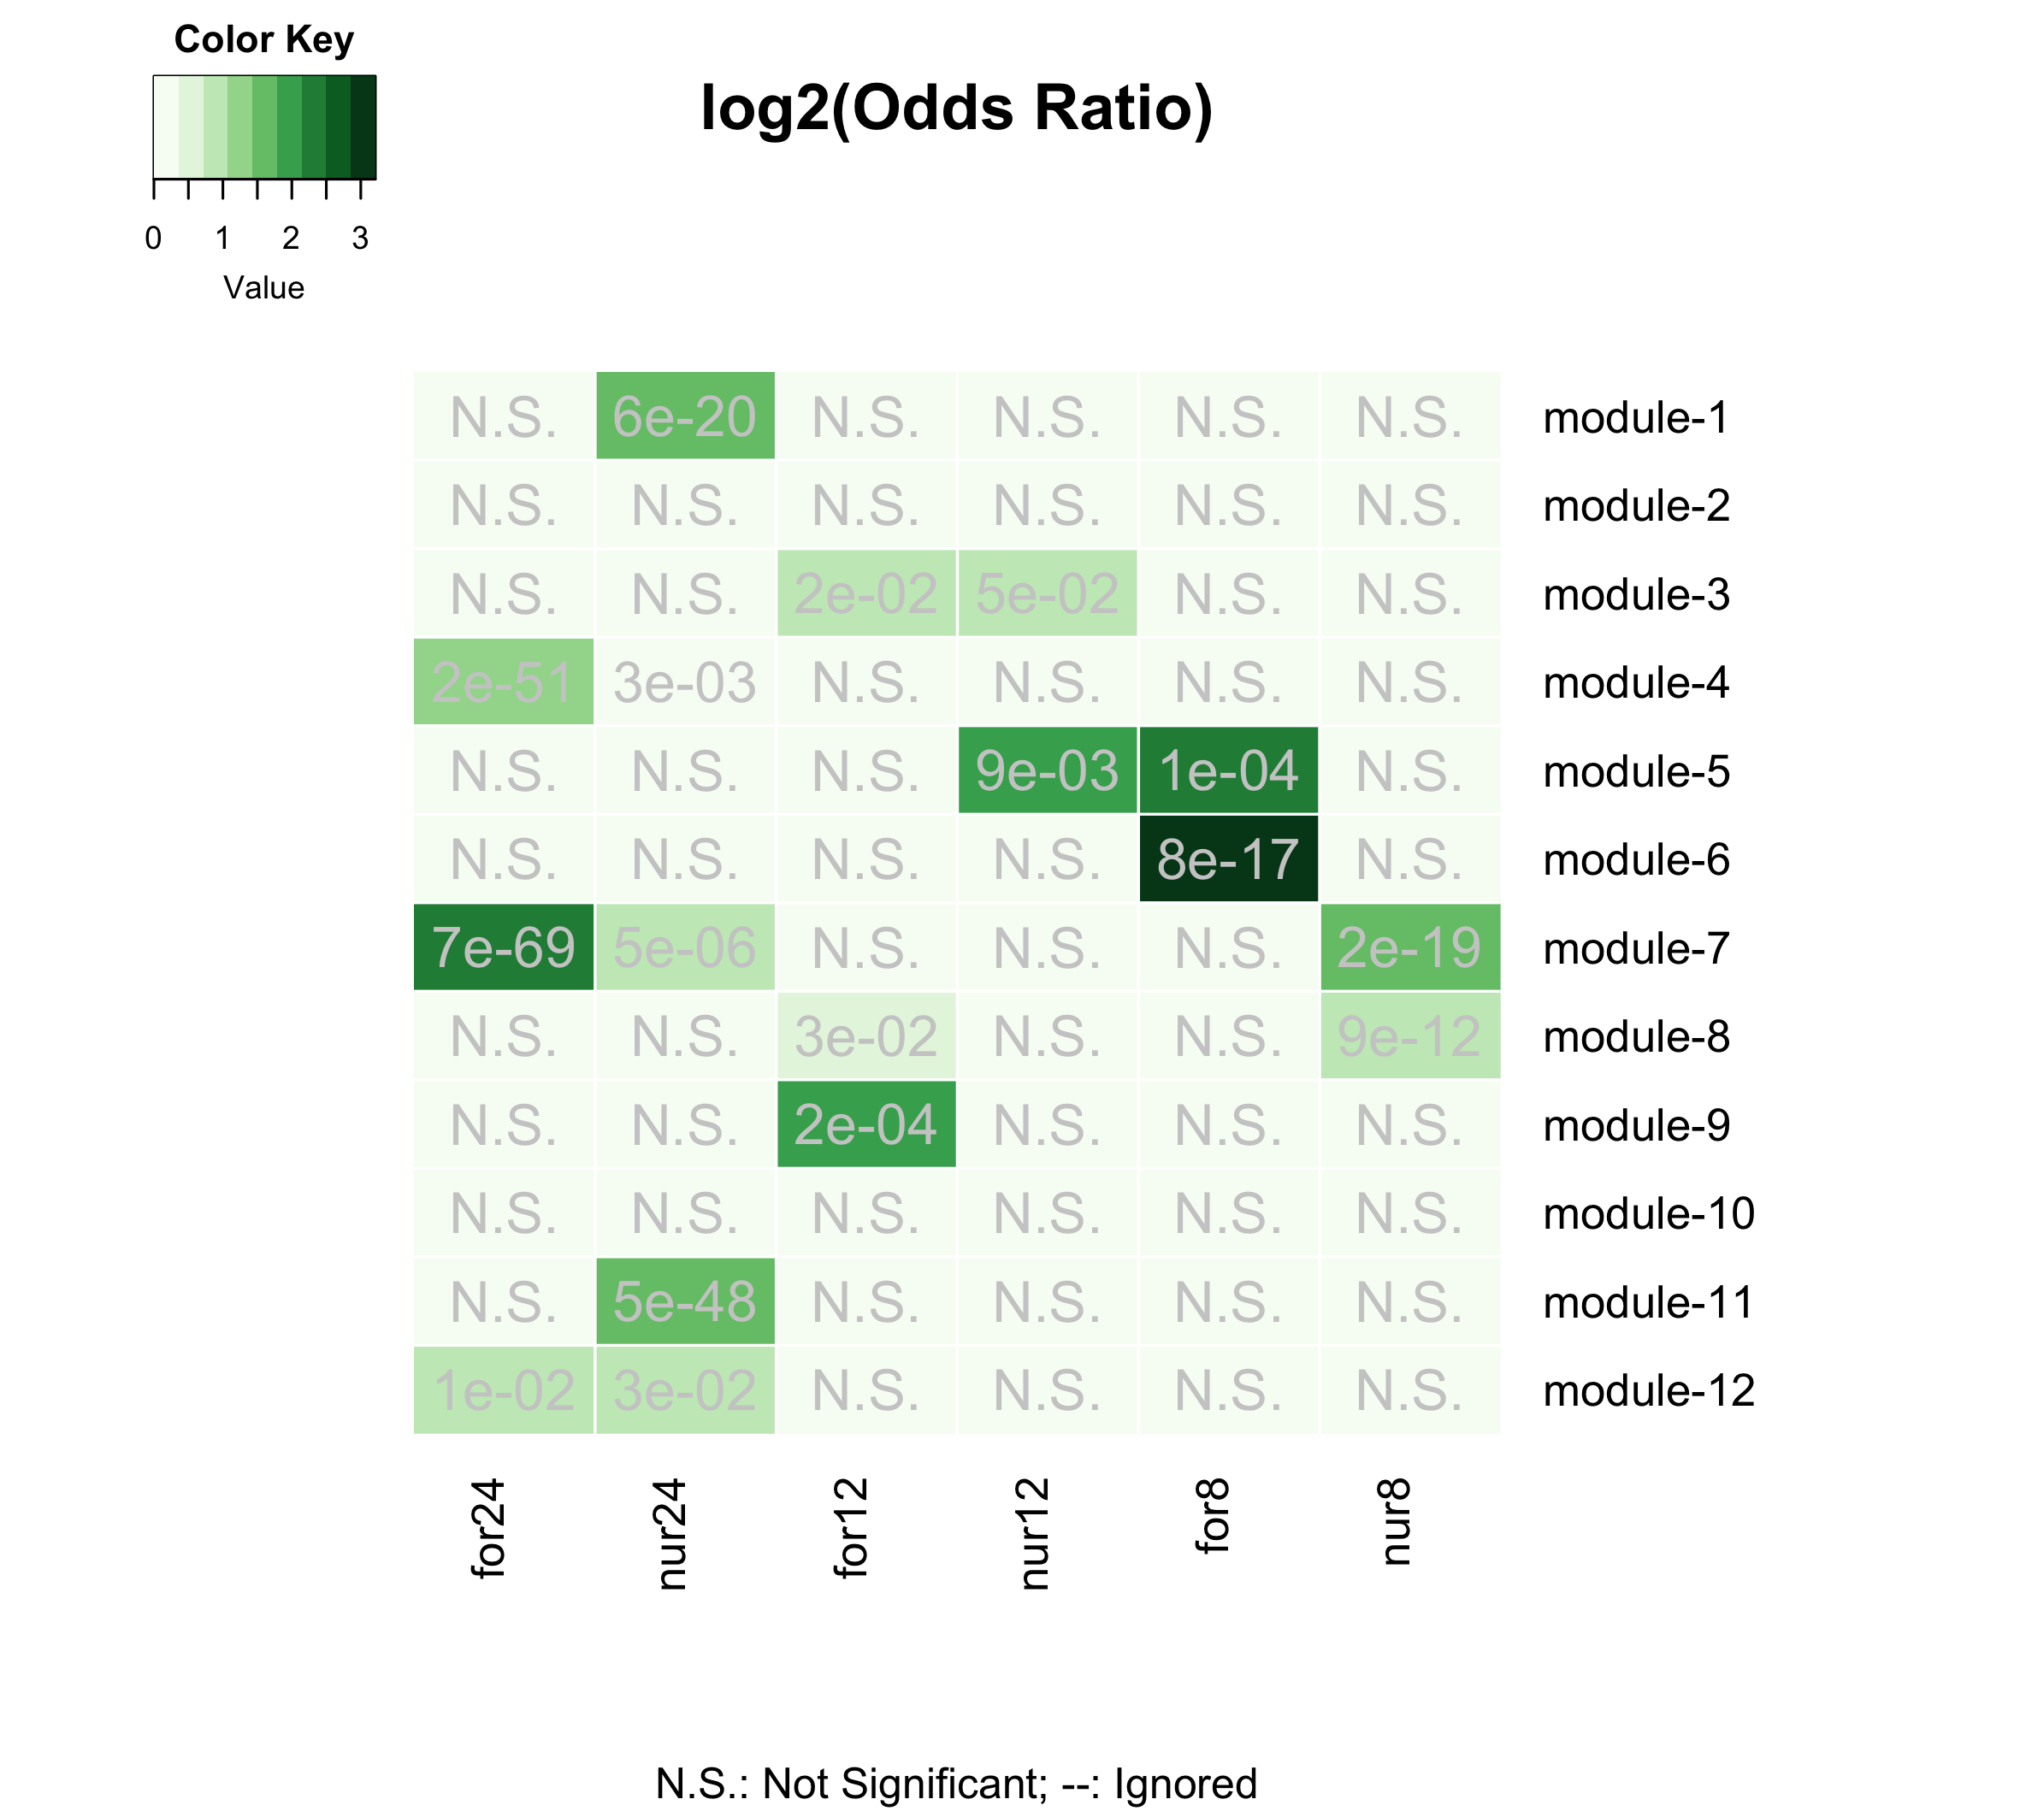

Figure 10. Gene-clusters with rhythmic genes: The matrix shows the results of the Fisher’s exact test performed for each module-geneset pair. The color of the boxes represents the odds-ratio (darker the green, higher is the odds-ratio) and the p-values are shown. The p-values were corrected for multiple-hypothesis testing using the Benjamini-Hochberg method. Non-significant overlaps between modules and genesets are indicated with a N.S. inside the box.

We found that the 24h-rhythmic genes were significantly overrepresented in five of the twelve modules of the ant GCN (module-1, module-4, module-7, module-11, and module-12) (Figure 10).

We further annotated the rhythmic modules by identifying which of these five modules contained genes that peaked during the day- and night-time in ant brains. To identify day- and night-peaking modules, we visualized the daily expression of all genes in the rhythmic modules as well as the module’s median gene expression (Figure 11). We found that module-4, module-11, and module-12 were day-peaking modules, whereas module-1 and module-7 were night-peaking modules.

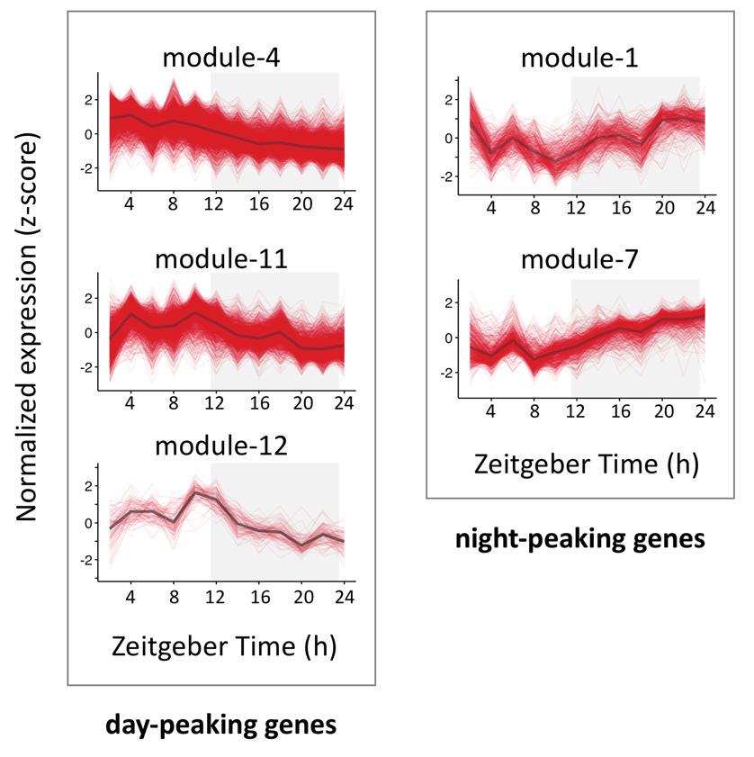

Figure 11. Daily expression patterns of genes in rhythmic modules: The daily expression pattern of all genes in a given module as well as the module’s median gene expression are shown. For a module, each red line represents the expression of one gene, every 2h over a 24h day and the black line represents the module’s median gene expression. The x-axis shows the time-of-day or Zeitgeber Time in hours, whereas the y-axis shows normalized gene expression (z-scores calculated from log2-transformed expression data). The 12h:12h light-dark cycles during which the samples were collected are also shown; white background indicates the light phase (lights on at ZT24/ZT0) and grey background indicates the dark phase (lights turned off at ZT12).

Using the same approach as above, we aimed to identify the ant modules that putatively underlie behavioral plasticity, as well as the modules that contained a significant number of genes that were affected during *Ophiocordyceps*-induced behavioral manipulation reported in a previous study that investigated gene expression in the heads of infected *C. floridanus* [5](Figure 12). The raw data of that study is deposited in NCBI under BioProject PRJNA600972 [5].

## Genes underlying behavioral plasticity  
 ## DEGS (foragers v. nurses)  
 # genes higher expressed in forager brains (v. nurse brains)  
 for.up <- tbl(db, "TC5_DEGs_all") %>% filter(upregulation=="for") %>% collect() %>% pull(gene_name)  
 # genes lower expressed in for. brains (v. nurse brains)  
 for.down <- tbl(db, "TC5_DEGs_all") %>% filter(upregulation=="nur") %>% collect() %>% pull(gene_name)  
  
## Genes underlying parasite-induced behavioral manipulation  
 ## DEGs (ophio-ant v. control-ant)  
 ophio.dat <- tbl(db, "ophio_biting_control") %>% collect() %>% select(gene, value_1, value_2, q_value:logFC)  
 ophio.dat <- ophio.dat %>%  
 filter(abs(logFC) >= 1 & significant=="yes" & q_value < 0.05) %>%  
 mutate(ophio = ifelse(logFC > 0, "down", "up"))  
 # genes higher expressed in ant heads during Ophio-manipulated biting (v. controls)  
 ophio.up <- ophio.dat %>% filter(ophio=="up") %>% pull(gene)  
 # genes lower expressed in ant heads during manipulated biting (v. controls)  
 ophio.down <- ophio.dat %>% filter(ophio=="down") %>% pull(gene)  
  
## LIST THREE - genes underlying behavioral plasticity and parasitic behavioral manipulation  
list3 <- list(for.up, for.down, # same as list three  
 ophio.up, ophio.down)  
names(list3) <- c("for-UP", "for-DOWN",  
 "ophio-UP", "ophio-DOWN")  
  
## CHECK FOR OVERLAP  
  
## make a GOM object  
gom.1v3 <- newGOM(list1, list3,  
 genome.size = nGenes)  
## visualize the overlaps  
drawHeatmap(gom.1v3,  
 adj.p=T,  
 cutoff=0.05,  
 what="odds.ratio",  
 # what="Jaccard",  
 log.scale = T,  
 note.col = "grey80")

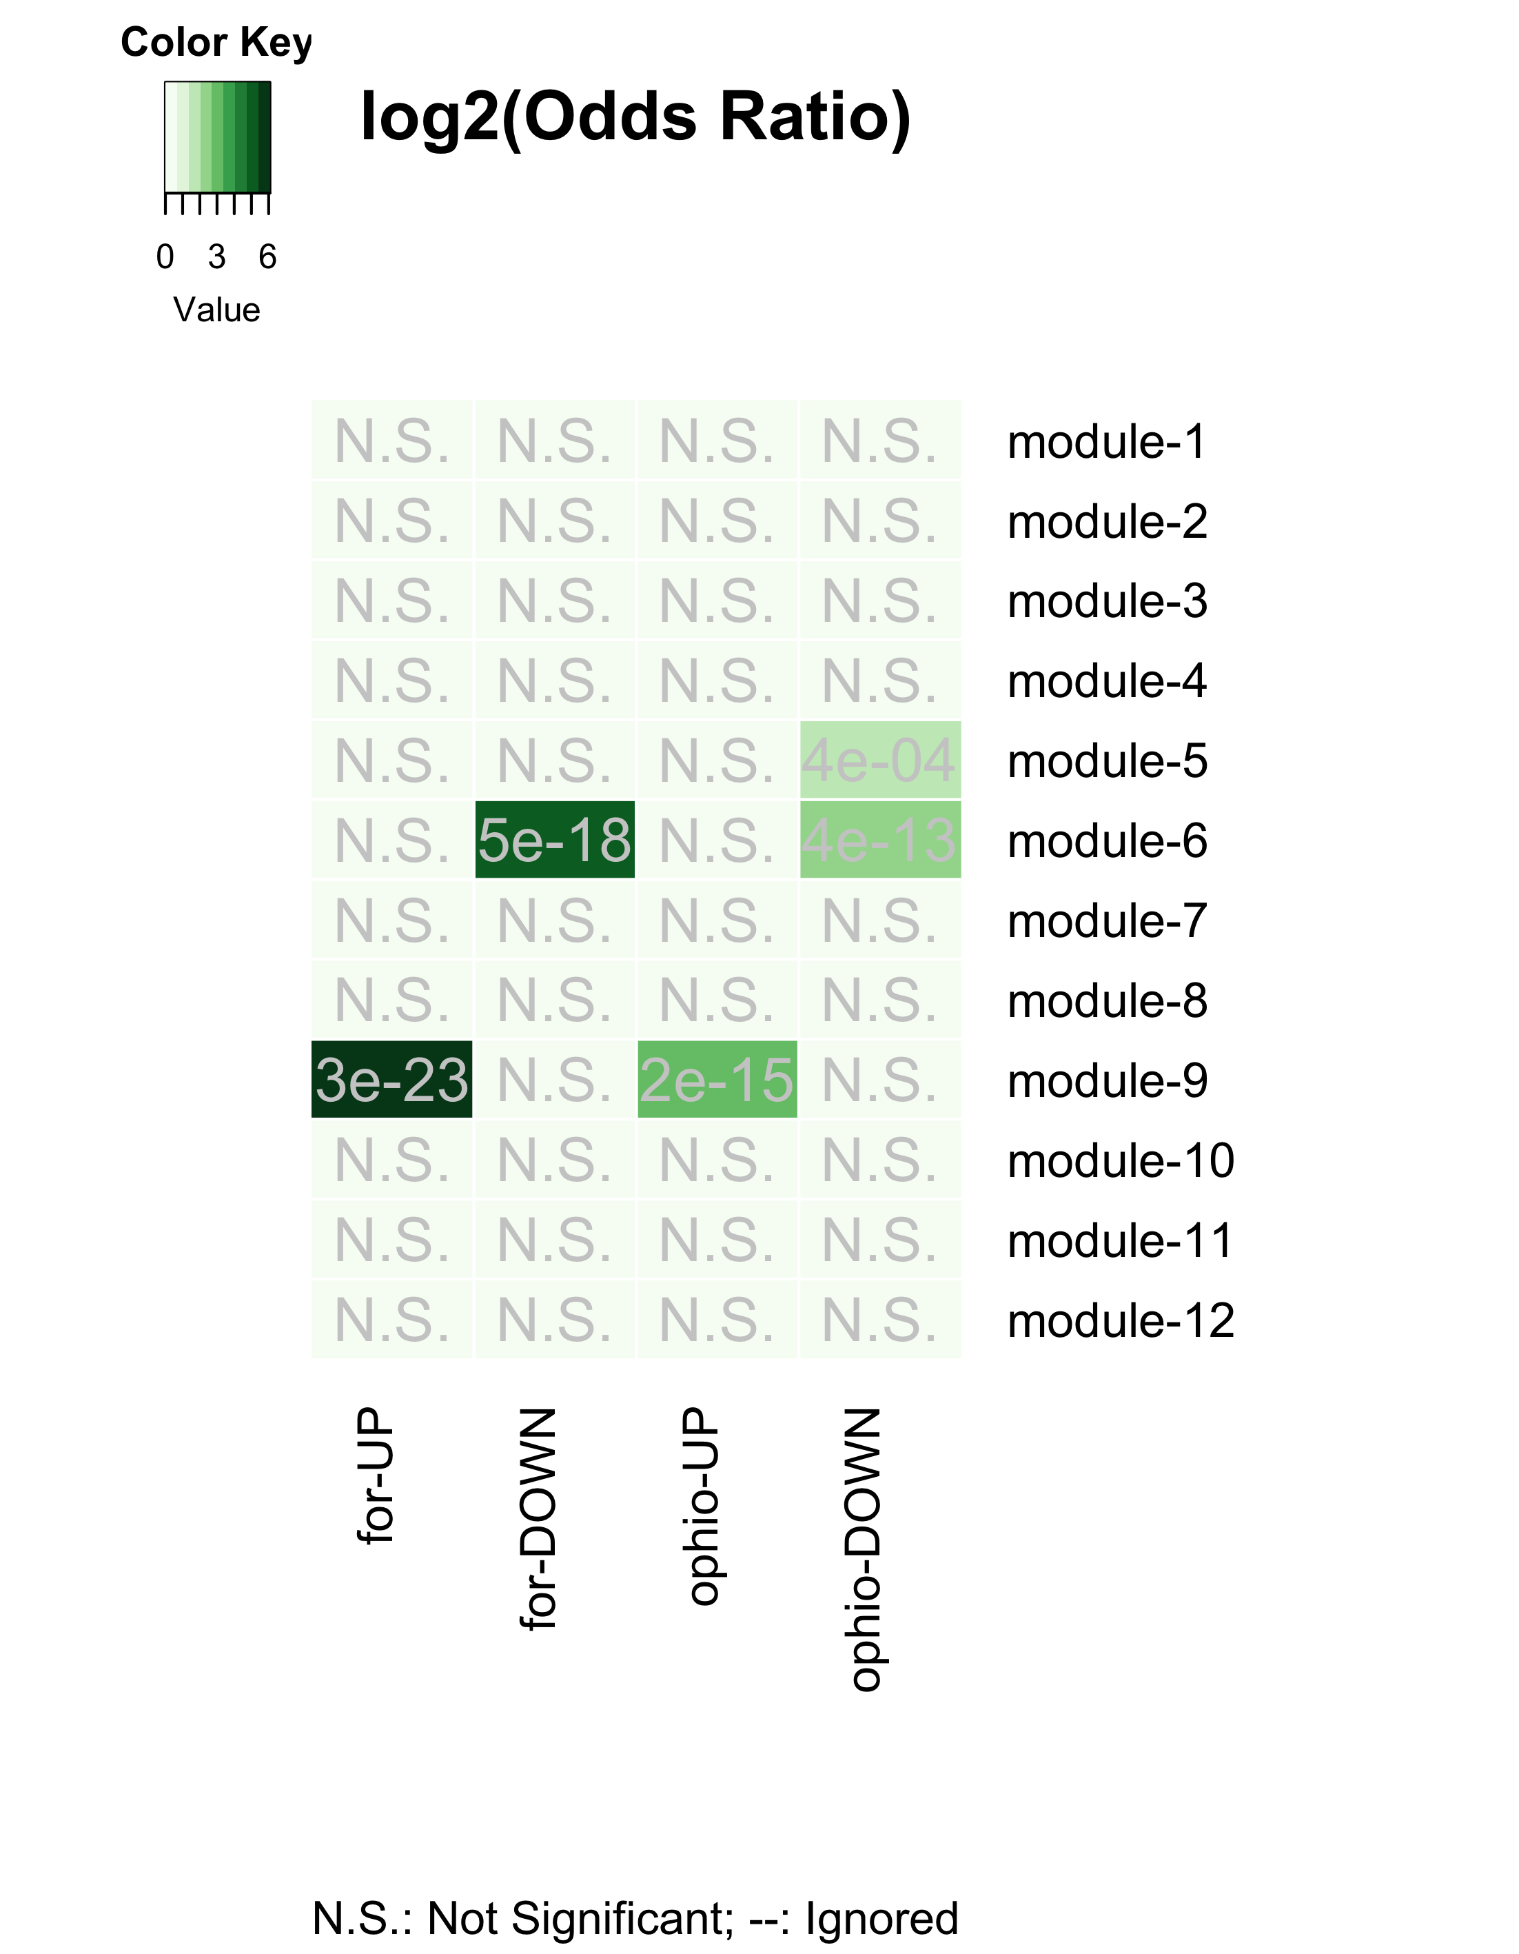

Figure 12. Gene-clusters with behavioral plasticity and parasitic behavioral manipulation genes: The heatmap identifies the different ant gene modules that are overrepresented in genes previously found to underlie behavioral plasticity (genes differentially expressed between foragers and nurses) (Das and de Bekker, BioRxv) and parasitic behavioral manipulation (genes differentially expressed in foragers during manipulated biting behavior) [5].

We found that the modules that contain an overrepresentation of genes that putatively underlie ant behavioral plasticity (i.e., differential expression in foragers as compared to nurses) and the modules that contain genes significantly affected during *Ophiocordyceps*-induced behavioral manipulation, are the same (i.e., modules 6 and 9) (Figure 12). In other words, to induce the characteristic manipulated biting behavior, the manipulating fungal parasite seems to be targeting the same genes and processes that otherwise allow ants to display behavioral plasticity (Figure 13). The modules that contain these genes appear to be closely connected to modules that contain an overrepresentation of rhythmic genes, suggesting that the expression of rhythmic genes and processes could also be (indirectly) affected by *Ophiocordyceps* infection.

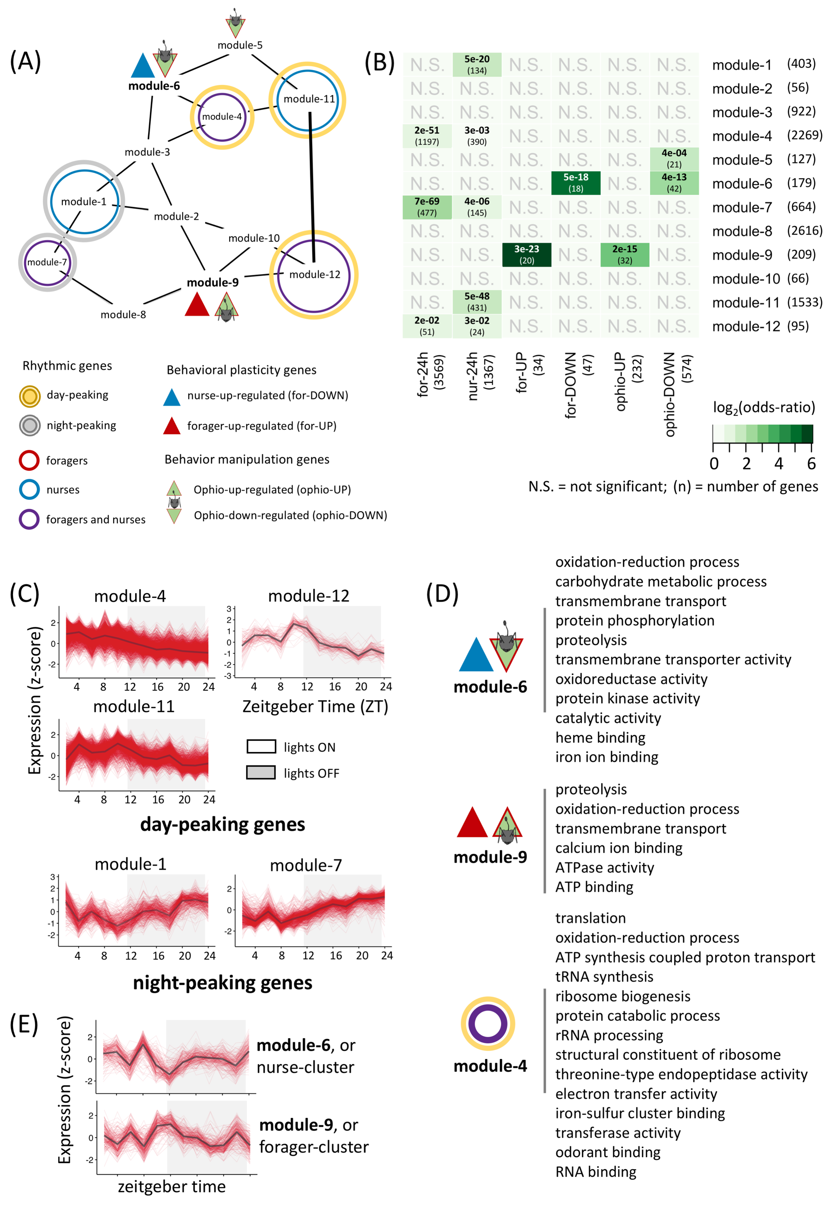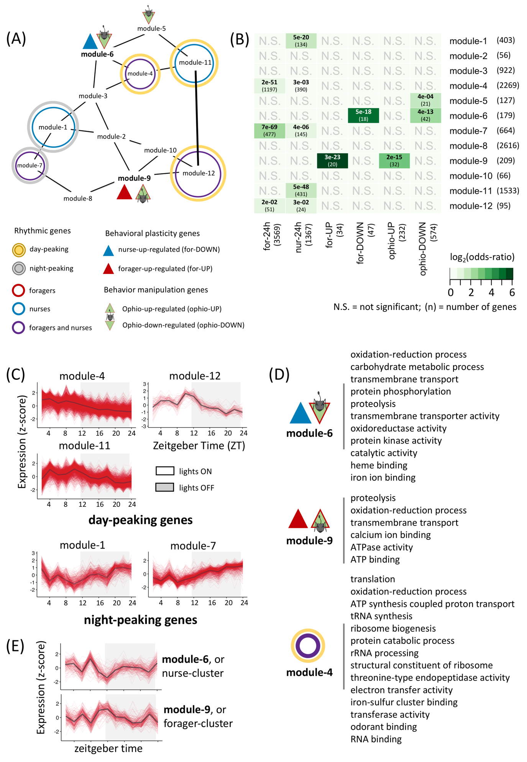

Figure 13. Annotated ant GCN: The annotated gene co-expression network summarizes the findings from our analyses and identifies different modules of interest that are putatively important for the interplay of rhythmicity, behavioral plasticity and parasitic behavioral manipulation.

## REFERENCES

1. Hutchison AL, Allada R, Dinner AR: **Bootstrapping and empirical bayes methods improve rhythm detection in sparsely sampled data.** *J Biol Rhythms* 2018, **33:**339-349.

2. Langfelder P, Horvath S: **WGCNA: an R package for weighted correlation network analysis.** *BMC Bioinformatics* 2008, **9:**559.

3. Csardi G, Csardi MG: **The igraph package.** Citeseer; 2007.

4. Shen L: **GeneOverlap: An R package to test and visualize gene overlaps.** *R Package* 2014.

5. Will I, Das B, Trinh T, Brachmann A, Ohm RA, de Bekker C: **Genetic Underpinnings of Host Manipulation by Ophiocordyceps as Revealed by Comparative Transcriptomics.** *G3 Genes|Genomes|Genetics* 2020, **10:**2275-2296.